NOVAC Technology Solutions



Software Requirement Specification

For

Claims Intimation Module for

Non Motor Health products

Revision History

Version No. | Date | Reason For Changes | Author | Reviewer | Approver
Draft 0.1 | 29-Dec-2023 | Health claim intimation draft version | v.swetha | S.arunkumar
Draft .2 | 30-Jan-2024 | Changes against the draft 0.1 | v.swetha | S.arunkumar
0.3 | 02-Feb-2024 | Changes against the draft 0.2 | v.swetha | S.arunkumar
Draft 0.4 | 19-02-2024 | Changes against the draft 0.3 | v.swetha | S.arunkumar
1.0 | 21-02-2024 | Baseline version of the draft 1.0 | v.swetha | S.arunkumar | Ms. Ankita Haldar

Table of Contents
1. Introduction 1
1.1 Purpose 1
1.2 Project Scope 1
1.2.1 Features for Future Releases 1
1.3 References 1
1.4 System Description 1
1.5 Stakeholders 2
2. Functional Requirements 2
2.1 Claim Intimation Module 3
2.1.1 Claim Intimation 3
2.2 Claim status 13
2.3 Health Claim Preliminary registration screen 14
2.4 Health claim registration screen 19
2.5 Assumptions and Dependencies 22
3. Interface Requirements 22
3.1 Internal Interfaces 22
3.1.1 Hardware Interface 22
3.1.2 Software Interface 22
3.1.3 Communication Interface 22
3.1.4 External Interfaces 22
3.1.4.1 Hardware Interface 23
3.1.4.2 Software Interface 23
3.1.4.3 Communication Interface 23
3.2 Operating Environment Requirement 23
3.2.1 Hardware Requirements 23
3.2.2 Software Requirements 23
3.2.3 Network Requirements 23
3.2.4 Operational scenarios: 23
3.3 Non Functional Requirements (NFR) 23
3.3.1 Reliability 23
3.3.2 Performance 23
3.3.3 Security 23
3.3.4 Usability 23
3.3.5 Other Requirements 23
3.4 Open Issues 24
3.5 Acceptance Criteria 24
4. Appendix A 24
5. Appendix A 24

Introduction

Purpose
The document is prepared to understand and build an Web portal, for intimation of claim under the Health Products.

Project Scope
The scope of the application is to perform the following.

Capture Policy details, Risk details, and provide intimation of Claim.

Out of Scope:

Other than mentioned in scope are out of scope.

Features for Future Releases

References

System Description
Claims can be Intimate based on the below functionality if the any off the below products has been purchased by the Insured.
  - Shri Criti care.
  - Shri Hospital Cash.
  - Shri Sarv care.
Note: If any new health product is launched in future then provision should be available for the same.

Process Flow:
- The purpose of this health claim intimation module is to facilitate the initiation/notification of health insurance claims.
- Following health products user can intimate/initiate the claim from this screen/module.
- SHRI HOSPITAL DAILY CASH
- SHRI CRITICARE INSURANCE
- SHRI SARV CARE
- SHRI ASHA
- SHRI GROUP HOSPITAL DAILY CASH (Not in live, future it is required)
- SHRI ABHI (Not in live, future it is required)
- SHRI SPECIALLY ABLED (Not in live, future it is required)
- SHRI AROGYA SANJEEVANI (Not in live, future it is required)
- This module may involves submitting basic details about the health accident, policy information, and other relevant details to initiate/intimate the health insurance claim.
- After providing basic mandatory details of the health incident & clicks on “Intimate a claim” button reference number will get generated and record will move to the “Health claim preliminary registration screen” of Nova CBS.
- The Health claims, which are intimated, will be able to check the claim status in portal under “Claim Status” screen.

Stakeholders

Stakeholder(s) | Relationship  (Client/Internal) | Roles and Responsibilities
Mr. Lingavel | Client | Client Representative
D Dinesh | Internal | Vice President
Vijay N Menon | Internal | Associate Vice President
CK Balaji | Internal | Project Manager
v.swetha | Internal | Business analyst
Saravana Muthu | Internal | Quality Manager

Functional Requirements
Need a provision in the system to intimate a health insurance claims. So there should be “claim Intimation” screen in the website & mobile.
In that screen, User need to enter the Information in the below mentioned sequence to complete the claim intimation journey.
- Policy details
- Member Details
- Hospital & Hospitalization details
- Upload documents
Once above mentioned mandatory details are provided & clicks on “Intimate a claim” then claim reference number will be generated & record will move to Preliminary claim intimation screen of Nova CBS, else claim will not be intimated.
Note: Field with * marked are mandate to be updated by the user, System should not allow users to proceed without mandate information

Claim Intimation Module

Claim Intimation
- On selecting “Intimate Claim”, user has to redirect to the following screen.
- There should be provision to select the Product line.
- Motor
- Non-Motor
- Health
- On selecting “Health”, existing health products list should be available for user selection.
- SHRI HOSPITAL DAILY CASH
- SHRI CRITICARE INSURANCE
- SHRI SARV CARE
- SHRI ASHA
- SHRI GROUP HOSPITAL DAILY CASH (Not in live, future it is required)
- SHRI ABHI (Not in live, future it is required)
- SHRI SPECIALLY ABLED (Not in live, future it is required)
- SHRI AROGYA SANJEEVANI (Not in live, future it is required)
- Once product has been selected then following screen has to be available for user action.
Sl. No. | FIELD NAME | FIELD TYPE | INPUTS | VALIDATION
Claim Intimation
1 | Policy Number | Alpha numeric |  | 1. User enterable.  2. This should be mandatory field.
2 | Insured’s Mobile number | Numeric field |  | 1. User enterable.  2. This should be mandatory field.  3. On clicking next button 4 digit OTP has to be triggered to the provided Insured’s mobile number.  Note: before triggering OTP, provided insured mobile number has to verify with policy insured mobile number., if matches then user should be allowed to proceed further, else error has to through invalid insured mobile number.  4. OTP should be valid for 30 mins and once one OTP triggered then resend OTP button should be enabled after 60 seconds.  5. On “resend” button New OTP has to trigger to insured mobile number.  6. User will be allowed 3 times to resend the OTP for every 30 mins.  4. OTP SMS template has been attached in references 1.3.  5.Post successful OTP verification, through policy number claim intimation journey has to start.  6.OTP authentication is not required for mobile claim intimation
3 | Next | Button |  | 1.On clicking this button, system has to check the provided policy number, if found policy against the same then following policy details has to auto fetch from the policy master & display and allowed the user to further action, else user will not be allowed to intimate a claim and throw the following error.  “No record found”
Policy details -head
For above provided policy number is valid then following policy details has to auto fetch from the policy master.
1 | Policy number | Auto populate & read-only |  | 1. This field has to auto populate & read-only from the policy master.
2 | Product Name | Auto populate & read-only |  | 1. This field has to auto populate & read-only from the policy master.
3 | Proposer Name | Auto populate & read-only |  | 1. This field has to auto populate & read-only from the policy master.
4 | Proposer mobile number | Auto populate & read-only |  | 1. This field has to auto populate & read-only from the policy master.
4.1 | Registered Email id | Auto populate & read-only |  | 1. This field has to auto populate & read-only from the policy master.
5 | Sum insured  No.of days/per day limit (it is for sarv care & hospital daily cash benefit) | Auto populate & read-only |  | 1. This field has to auto populate & read-only from the policy master, If available.
5.1 | Alternative mobile number | Numeric field |  | 1. User Enterable.  2. This should be Non- mandatory field.  3. Mobile number validations should applicable here.
5.2 | Alternative Email id |  |  | 1. User Enterable.  2. This should be Non-mandatory field
Member details head
Against the policy number available members has to be list out for user selection.
6 | Member | Drop down |  | 1. User selection.  2. This should be mandatory field.  3. All the members, which are available against the policy, has to display from the policy master.  4. Based on the member selection following member details (sl.no 7 to12) has to be auto fetch & display in read-only manner.  5. Multiple member selection should not be allowed.
7 | Member name | Auto populate & read-only |  | 1. This field has auto fetch & read-only from policy master.
8 | Member ID | Auto populate & read-only |  | 1. This field has auto fetch & read-only from policy master.
9 | DOB | Auto populate & read-only |  | 1. This field has auto fetch & read-only from policy master.
10 | Gender | Auto populate & read-only |  | 1. This field has auto fetch & read-only from policy master.
11 | Plan type | Auto populate & read-only |  | 1. This field has auto fetch & read-only from policy master.
12 | Sum insured | Auto populate & read-only | This field is not applicable for Hospital daily cash product | 1. This field has auto fetch & read-only from policy master.
13 | No. of days limit | Auto populate & read-only | This field is applicable for hospital daily cash & sarv care | 1. This field has auto fetch & read-only from policy master.
14 | Per day limit | Auto populate & read-only | This field is applicable for hospital daily cash & sarv care | 1. This field has auto fetch & read-only from policy master.
Hospital & hospitalization Details
13 | Claim Type | Drop down | 1.Cashless  2.Reimbursement | 1. User selection.  2. This should be mandatory field.  3.As of now, reimbursement alone has to be enabled.
14 | Treatment type | Drop down | 1.Indoor Hospitalization – Emergency  2.Outpatient (OP) Treatment  3.Indoor Hospitalization – Planned  4. Day care Treatment  5. Home care Treatment | 1. User selection.  2. This should be mandatory field.  3. Outpatient treatment & home care treatment will not be applicable for shri hospital daily cash.
15 | Name of the Hospital/clinic | Free text field |  | 1. Based on the user input, hospital list has to prepopulate for user selection, if hospital name is not available in the in the list then use should be allowed to enter manually & entered details should stored in hospital master.
16 | Hospital state | Auto populate & editable |  | 1. Based on the hospital name, it has to auto populate from the hospital master.  2. If hospital name is not available In the list & user provided manually then this field should be use enterable & mandatory.
17 | Hospital City | Auto populate & editable |  | 1. Based on the hospital name, it has to auto populate from the hospital master.  2. If hospital name is not available In the list & user provided manually then this field should be use enterable & mandatory.
18 | Hospital/Locality | Auto populate & editable |  | 1. Based on the hospital name, it has to auto populate from the hospital master.  2. If hospital name is not available In the list & user provided manually then this field should be use enterable & mandatory.
18.1 | Type of hospital | Auto populate & read-only |  | 1. Based on the hospital name, it has to auto populate from the hospital master.  2. If type of hospital is excluded provider then following error message has to display.  “Expenses incurred towards treatment in this hospital is not admissible, since it is an Excluded Provider”.
18.2 | Have you verified if the Hospital is an excluded provider? | Check box | 1.Yes  2.No | 1. User selection.  2. This field should be enabled & mandatory, if user enters the hospital name/clinic field manually (i.e. Hospital name not available in the list).  3. There should be hyperlink, Excluded provider list”, on clicking the same all the excluded provider list should be available In view mode.
19 | Room Type | Drop down | 1.Single AC  2. Single NON AC  3.Double AC  4 Double NON AC  5.Multi bedded room or general ward AC  6. Multi bedded room or general ward NON AC  7.Deluxe  8.Suite  9.ICU  10. Others | 1. User selection.  2. This should be mandatory field.
20 | Date of admission | Date picker |  | 1. User Selection.  2. This should be Non-Mandatory Field.  3.This field should be mandatory for Shri Hospital daily cash/Shri sarv care
21 | Date of discharge | Date picker |  | 1. User Selection.  2. This should be Non-Mandatory Field.  3 Date of discharge cannot be before the date of admission
21.1 | Is the Insured Patient discharged from hospital? | Drop down | 1. YES  2. NO | 1. User selection.  2. This should be mandatory field.
22 | Diagnosis/treatment details or Name of the ailment for which claimed | Free text field |  | 1. User selection.  2. This should be mandatory field
23 | Expected cost of treatment | Numeric field |  | 1. User Enterable.  2. This should be mandatory field.
23.1 | Eligible benefit amount | Numeric field |  | 1. User Enterable.  2. This should be non-mandatory field.
24 | Patient Status | Drop down | 1.Discharged in Good Health  2.Discharged with Follow-up recommended  3.Discharged against Medical Advice  4.Transferred to Higher centre  5.Discharged for Hospice care  6.Discharged for Home care  7.Physical Disability  8.Deceased | 1. User selection.  2. This should be Non- mandatory field
25 | Mode of treatment | Drop down | - Surgical  - Non-Surgical | 1. User selection.  2. This should be mandatory field
Ambulance details
This section should be enabled for the product ASHA & For the product, which is having add on/rider of ASHA. (I.e. sl.no 26 to 28.2)
26 | Ambulance provider name | Free text field |  | 1. User enterable.  2. This should be mandatory field.
27 | Ambulance From | Free text field |  | 1. User enterable.  2. This should be mandatory field.
28 | Ambulance To | Free text field |  | 1. User enterable.  2. This should be mandatory field.
28.1 | Distance travelled in Ambulance | Numeric field |  | 1. User enterable.  2. This should be mandatory field.  3.Max 3 digits will be allowed.
28.2 | Ambulance charges paid amount | Numeric field |  | 1. User enterable.  2. This should be mandatory field.
29 | Documents | Drop down | 1.Claim form – dully filled and signed (original)*  2.NEFT Details And Cancelled cheque leaf*  3.FIRST CONSULTATIONS PAPERS*  4.DISCHARGE SUMMARY*  5.Final bill with break ups  6. All lab reports and radiology reports and images*  7.MLC report / FIR / ACCIDENT REGISTRATION REPORT*  8.Any Other Documents | 1. User selection.  2. This should be Non-mandatory field.  3. This should be mandatory in case –  “Is the Insured Patient discharged from hospital?” is selected as “YES”! Only one document should be mandatory in this case  “Discharge summary”  In this case In error message “Please upload Discharge summary” has to show.
30 | Upload | Button |  | 1. on clicking upload button system has to allow the user to select the document from local file & on upload document will be uploaded.  2. There should be provision to view/delete the uploaded documents but delete should not be allowed post claim reference number generation.  Note: Once claim reference number has been generated then upload documents can be save against that claim reference number.
31 | Submit | Button |  | 1. On clicking this button system has to check all the mandatory validations & allow the user to submit, else should not allow the user to proceed further.  should throw the following error  “ all mandatory fields should be completely filled”  2. Once file is submitted, “claim reference number has to generate” successfully.  Reference number format: branch code/product code/FY/reference/serial number  421010/73/24/R/000001  3. Post generation of claim reference number record has to be moved to “Health claim Preliminary registration screen” of nova CBS.  4. The claim which are intimated in website/mobile/CHD portal/hospital portal has to be available In Claim status” screen. (i.e. if user is checking the status then it should be available).  5. SMS communication has to triggered to insured on claim intimation.  (format attached in references 1.3)
For claim intimation via CHD portal , Website , Mobile application and Hospital , Once the claim related details are submitted by the customer or by CHD user or the Hospital, claim reference number to get generated , then auto email (with intimation letter pdf) and text messages to get triggered to the customer’s registered mobile number template attached references 1.3

Claim status
- There should be provision in the website & mobile to check the claim status.
- On clicking “claim status” mobile field should be enable for OTP authentication, user should be allowed to check claim status journey after OTP verification/authentication.
- OTP SMS template has been attached in references 1.3
Sl. No. | FIELD NAME | FIELD TYPE | INPUTS | VALIDATION
Claim status
1 | Claim number/claim reference number/policy number | Free text field |  | 1. User enterable.  2. This should be mandatory field.
2 | Search/Proceed | Button |  | 1.On clicking this button, all the claims (i.e. past, current, future claims) has to show with following details  2. If user searched through policy number then all the claims (i.e. past, present, future claims) against that policy number should display.
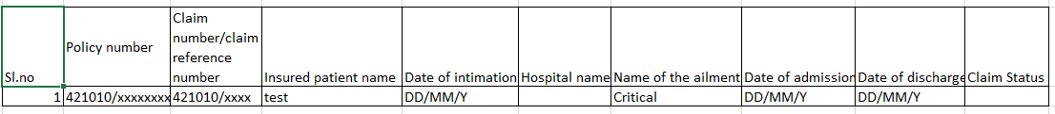
If claim status is “medical query” then there should be provision to upload the medical query documents. So there should be hyperlink called upload documents, on clicking the same user should be allowed to upload & submit the documents.
Uploaded documents should store against the claim number/claim reference number and it has to reflect in preliminary registration screen, claim registration, processing & settlement screens.

FYI, below sections (i.e. 2.3, 2.4) has been provided in the SRS.

Health Claim Preliminary registration screen
Sl. No. | FIELD NAME | FIELD TYPE | INPUTS | VALIDATION
Health claim preliminary registration- Dashboard
- In this dashboard, all the claims, which are intimated via Hospital portal, CHD portal, website, mobile application, has to reflect.
- In dashboard, record has to show with following details in the grid.
a)Claim reference number
b) Policy number
c)Source of the claim
d) Product Name
e) Hospital name
e)Intimation date & time
f)Name of the ailment
g)Status
h) Action

1 | Search By | Drop down | 1.Policy Number 2.Claim Number 3.Member Id  4.Insured Name 5.Product Name 6.Branch  7.Claim reference number | 1. User selection.  2. This should mandatory field.
2 | Clear | button |  | 1. On clicking this button, inputted data has to clear.
3 | Edit | Button |  | 1. On clicking this button, Health claim preliminary registration screen has to open with following details.  a) Policy Information  b)claim Intimation
Policy Information tab:
All the policy details has to show in this tab.
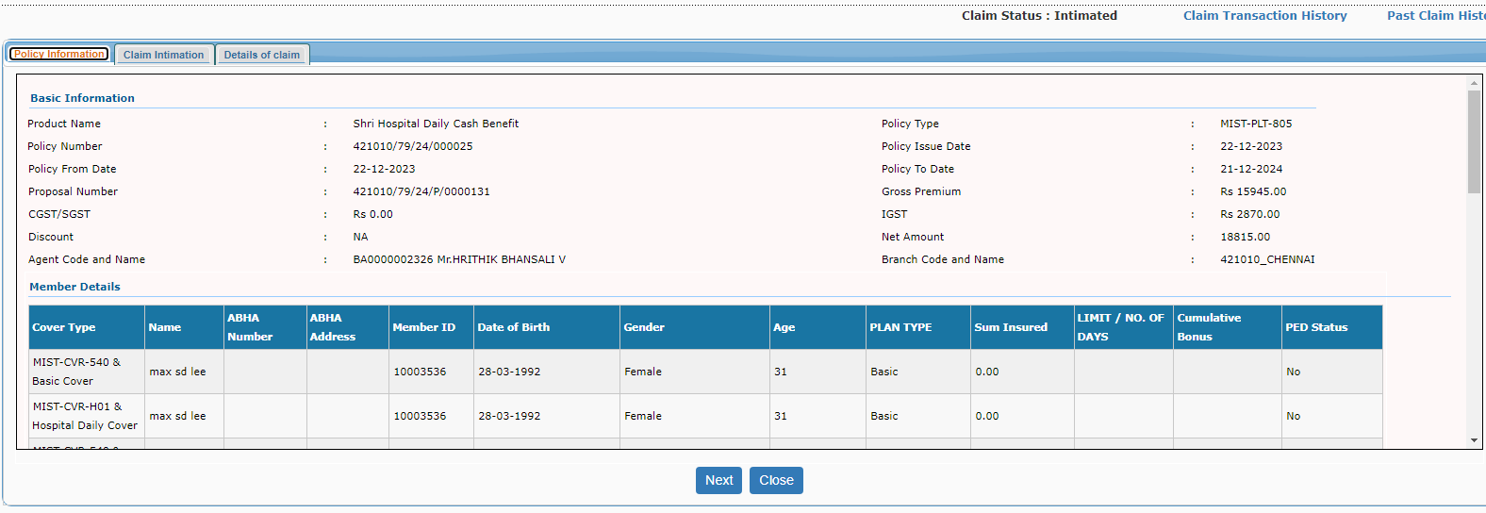
Claim Intimation-Tab
- The existing tab which is available in health claim registration screen has load & the details which are provide in website/mobile/CHD portal/hospital portal has to auto populate & display in respective fields of claim intimation tab.
- Other than fetched fields (i.e. from website/mobile/CHD portal/hospital portal), user has to fill all other mandatory fields. Mandatory should be product specific.
Heads in claim intimation tab;
- Registration – New field has to add in this head “Occupation of insured patient/beneficiary” (free text field). This field has to enable & mandatory, if insured patient/beneficiary is child”)
- Hospital details – New field to be added in this head “ Estimated cost of treatment” (numeric field) and mandatory
- Outpatient details.
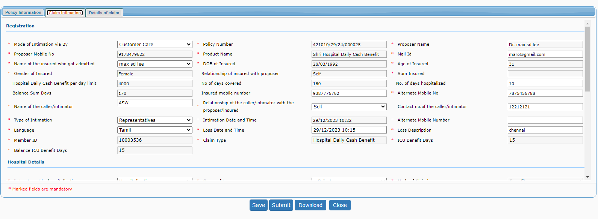

Ambulance details
This section should be enabled for the product ASHA & For the product, which is having add on/rider of ASHA.
This tab has to auto populate form the portal/mobile/CHD portal/Hospital portal)
26 | Ambulance provider name | Auto populate & read-only |  | 1.This field has to auto populate & read-only from portal/mobile/CHD portal/Hospital portal)
27 | Ambulance From | Auto populate & read-only |  | 1.This field has to auto populate & read-only from portal/mobile/CHD portal/Hospital portal)
28 | Ambulance To | Auto populate & read-only |  | 1.This field has to auto populate & read-only from portal/mobile/CHD portal/Hospital portal)
28.1 | Distance travelled in Ambulance | Auto populate & read-only |  | 1.This field has to auto populate & read-only from portal/mobile/CHD portal/Hospital portal)
28.2 | Ambulance charges paid amount | Auto populate & read-only |  | 1.This field has to auto populate & read-only from portal/mobile/CHD portal/Hospital portal)
4 | Save | Button |  | 1. On clicking this button details has to be saved partially.
5 | Pre-Register | Button |  | 1. On clicking this button system ha to check all the mandatory validations, else validation error has to throw.  “ Please fill all the mandatory fields”  2.Post successful checking of mandatory validation’s, record has to move to ‘Health claim registration” & status has to be “Pre-registered”  3. From Health claim registration screen, existing flow has to be followed. (i.e., claim number generation, and further process of the claim like uploading of any additional claim related documents , query related documents ,will continue in the existing registration – processing and settlement screen)
6 | Deny | Button |  | 1. On clicking this button, “reason for deny” field has to be enabled & mandatory.  2. Post that, Details has to be saved & record should not move to Health claim registration screen”.  3.Communication letter has to be triggered to the insured with claim reference number on denial of claim.  4.Denial of claim pdf letter has to trigger to the insured through mail  Note: Format attached in references 1.3.
 | Reason for Deny | Drop down | - initial waiting period  - 2years waiting period  - PED waiting period  - Ailment is not covered  - No 24-48 Hours Hospitalization ( this to be disabled for criticare ) | 1. User selection.  2. This field has to enabled & mandatory, if user clicks on “deny” button.
 | Upload | Button |  | 1. Document of upload should be non-mandatory in health preliminary registration screen.  2. There should be provision to upload the documents & it should reflect in health claim registration & processing screen with following details.  a. Name of the file.  b. Name of the category  c. Uploaded user ID & Name  d. Uploaded date & time
7 | Close | Button |  | On clicking this button, system has to navigate the user to dashboard screen.

Health claim registration screen
- All the claims which are intimated by website/mobile/ CHD portal/ hospital portal has to reflect health claim preliminary registration screen and claim registration screen.
- Once record submitted from preliminary registration screen then it has to reflect in claim registration screen.
- In registration, all the relevant fields should have pre filled from preliminary registration screen with editable rights.
- All the documents, which are uploaded in preliminary registration screen/mobile/website/hospital portal, has to reflect in health claim registration screen & processing screen.
- There should be hyper link called “health Preliminary- registration screen” in claim registration, processing and claim settlement.
- Once record moved from health preliminary registration to health claim registration screen then flow, functionality & validation will same as existing.

Sl. No. | FIELD NAME | FIELD TYPE | INPUTS | VALIDATION
Health claim registration- Dashboard
- The claims, which are Pre-registered & Deny, has to reflect in health claim registration screen dashboard with following parameters.
- Claim reference number
- Source of the claim intimation
- Intimation date & time
- Insured Patient Name
- Product name
- Policy number
- Member ID
- Policy start date
- Policy end date
- Status
- Action

1 | Search By | Drop down | 1.Policy Number 2.Claim Number 3.Member Id  4.Insured Name 5.Product Name 6.Branch  7.Claim reference number  8.Claim status | 1. User selection.  2. This should mandatory field.
2 | Clear | button |  | 1. On clicking this button, inputted data has to clear.
3 | Action | Button |  | 1.On clicking this button, the data has to be pre filled from health claim preliminary registration screen with editable rights, remaining data has to be filled by registration screen user.  2.From registration screen onwards, exsiting flow has to be continued.

In claim registration, in “search criteria” claim reference number has to include
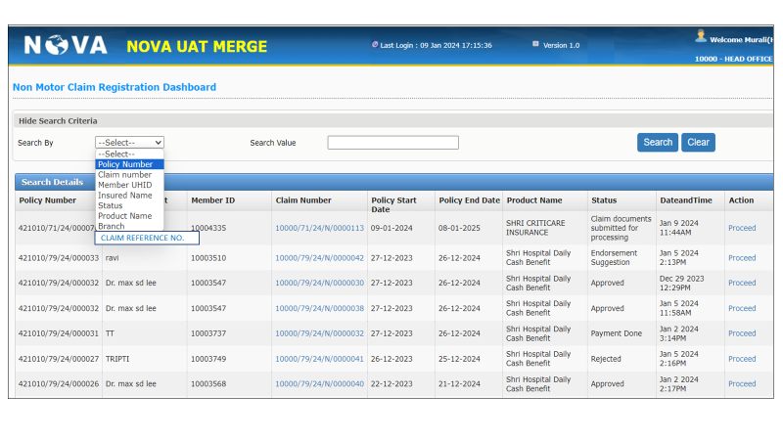
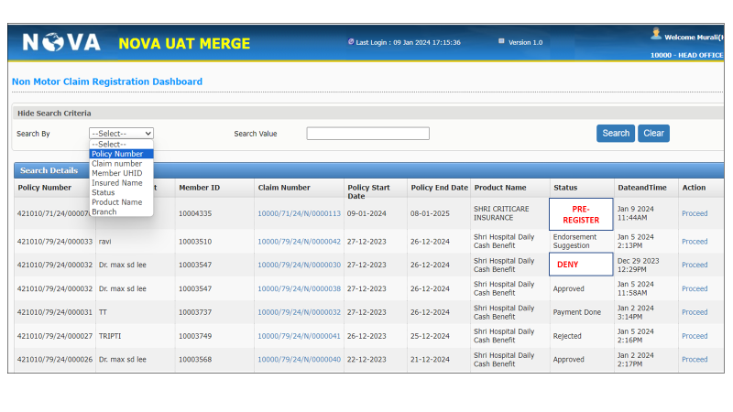

Assumptions and Dependencies
S. No. | Assumptions | Dependencies in Project
1 | No other functionality includes fields, filed types, validations will be handled other than the functionality mentioned above | No Dependencies
2
3

Interface Requirements
The claim intimation module will have interface with the new business module.

Internal Interfaces
- The document is prepared to understand and build an Web portal, mobile application, CHD for intimation of claim under the Health Products I.e. Shri Criticare, Shri Hospital daily Cash, Shri Sarv care,
- Involves different applications
- Core application , Web portal, mobile application, CHD portal application, Hospital portal application.
- From the core, application data will flow to the above-mentioned applications.
- From various applications(i.e. above mentioned application), data will move to core application for claim process.

Hardware Interface
<Not Applicable>

Software Interface
<Not Applicable>

Communication Interface
<Not Applicable>

External Interfaces

Hardware Interface
<Not Applicable>

Software Interface
<Not Applicable>

Communication Interface
<Not Applicable>

Operating Environment Requirement
<Not Applicable>

Hardware Requirements
<Not Applicable>

Software Requirements
<Not Applicable>

Network Requirements
<Not Applicable>

Operational scenarios:
<Not Applicable>

Non Functional Requirements (NFR)

Reliability
<Not Applicable>

Performance
<Not Applicable>

Security
<Not Applicable>

Usability
<Not Applicable>

Other Requirements
<Not Applicable>

Open Issues
<Not Applicable>

Acceptance Criteria
- Functional testing will be executed by internal testing team, and the same will be delivered to client for UAT.

Appendix A
Not Applicable

Appendix A
Not Applicable

